CHILD CARE
EMERGENCY PREPAREDNESS GUIDELINES

KIDTIME, INC.
@
Farragut Primary School

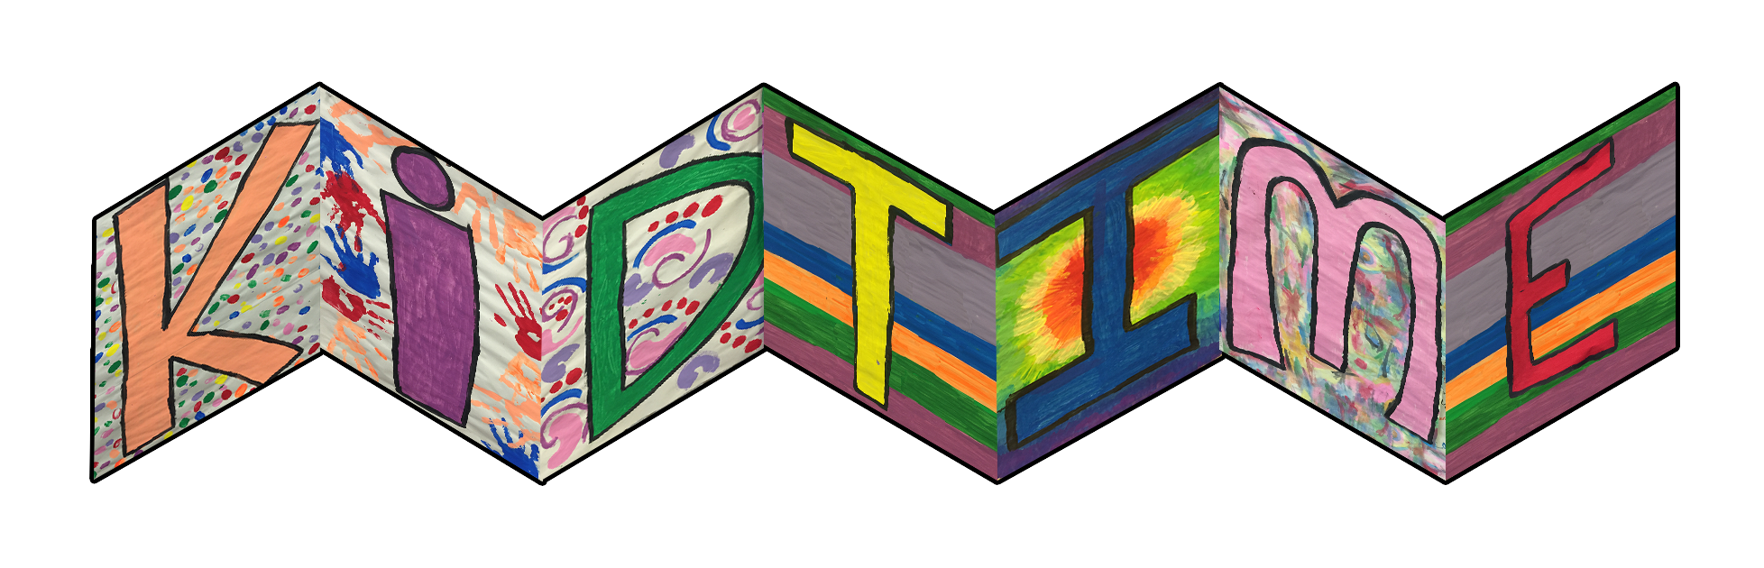

Developed For
KidTime, Inc.
By Knoxville Education Consultants
P.O. Box 22834
Knoxville, TN 37933-0834
Tel: (865) 740-1803

TABLE OF CONTENTS

KIDTIME'S CHILD CARE EMERGENCY PREPAREDNESS GUIDELINES 1
OVERVIEW 1
FIVE STEP PLAN 1
STEP ONE: PREPARATION AND EDUCATION 2
PREPARATION 2
SUPPLIES 2
SHELTER 2
MEDICATIONS 2
SAFETY 3
EVACUATION 3
TRANSPORTATION 3
RESPONSIBILITY 3
INJURY 4
EDUCATION 5
EDUCATION PLAN 5
FLOOR PLAN 5
STEP TWO: AN EARLY WARNING SYSTEM 6
STEP THREE: AN EVACUATION PLAN 6
EVACUATION 6
EVACUATION PLAN I - WITH MOTOR VEHICLES 7
EVACUATION PLAN II - BY FOOT 8
CALLING 911 8
STEP FOUR: A PLAN FOR SAFETY SURVIVAL UNTIL HELP ARRIVES 9
PLANNING GUIDELINES FOR SPECIFIC HAZARDS 9
MEDICAL - INJURY OR ILLNESS OF CHILD OR STAFF 9
SEVERE COLD WEATHER CONDITIONS 10
SEVERE HEAT WAVE 11
TABLE: Heat and Humidity and the Possible dangers 11
TABLE: Heat Disorder Symptoms 11
SEVERE HEAT WAVE PLAN 12
ANIMAL EMERGENCY 12
TORNADO 12
DEFINITIONS 12
TORNADO PLAN 13
EARTHQUAKE 14
DURING AN EARTHQUAKE 14
AFTER AN EARTHQUAKE 14
ACCESS DAMAGE 15
FLOOD 15
EQUIPMENT FAILURE 15
FIRE AND EXPLOSION 16
HAZARDOUS MATERIAL ACCIDENT / NUCLEAR WAR 17
POWER FAILURE 17
LAW ENFORCEMENT EMERGENCY 17
BOMB THREAT 18
STEP FIVE: A PLAN TO REUNITE CHILDREN WITH THEIR PARENTS 18
APPENDIX 20
EMERGENCY TELEPHONE NUMBERS 20
ATTACHMENTS 21
FLOOR PLAN FOR A.L. LOTTS 21
FIRE DRILL PLAN 22
CIVIL DEFENSE PLAN 23
FIRE DRILL PROCEDURES 24
BOMB THREAT DOCUMENTATION 25
SOURCES 26
A.L. Lotts Elementary School 26
Knox County Emergency Management Agency 26
Tennessee Department of Human Services 26
Tennessee Emergency Management Agency 26

KIDTIME’S CHILD CARE
EMERGENCY PREPAREDNESS GUIDELINES

OVERVIEW

KidTime, Inc. is responsible for the students, who attend its after school program at Farragut Primary School. If an emergency should arise, this plan will provide courses of action for the most common emergencies. Although no plan can address all possible occurrences, which might develop in an actual emergency, having a plan in place can improve our response time and increase our ability to obtain the best possible outcome.

It is our objective to provide for the safety of all students and staff, to continue operation in the event of disaster, and to ensure that the students, parents and staff know the emergency plan.

An emergency is any unplanned event that can disrupt operations, shut down KidTime, cause physical/environmental damage, or can cause significant injuries to staff and children.

In developing this plan, we have taken some preliminary steps to be prepared in the event of medical emergencies, severe cold weather conditions, severe heat, animal emergencies, tornadoes, earthquakes, floods, equipment failure, fire and explosions, hazardous material accidents/nuclear war, power failure, law enforcement emergencies, and bomb threats.

FIVE STEP PLAN

These guidelines detail KidTime’s five step plan:

Step One: Preparation and Education
Step Two: An Early Warning System
Step Three: An Evacuation Plan
Step Four: A Plan for Safety Survival until Help Arrives
Step Five: A Plan to Reunite Children with Their Parents

STEP ONE: PREPARATION AND EDUCATION

PREPARATION

SUPPLIES

The following supplies will be at KidTime:

- First Aid Kit
- Water (for 24 hours)
- Food (for 24 hours, nonperishable)
- Diapers
- Paper Supplies
- Portable Radio and fresh batteries
- Gloves
- Shovels
- Flashlight and fresh batteries
- Manual can opener
- Blankets/Coats for staff and students
- Mats (in gym)
- Masking Tape
- Medications in locked medicine box

SHELTER

If KidTime remains habitable following a disaster, we will provide an alternate source of toileting and use supplies listed above to provide comfort from the cold and to use for sleeping for all staff and children.

MEDICATIONS

A 24-hour supply of prescribed medications (with round the clock instructions) is kept available for staff and children with chronic health needs. There is a first aid kit located in the cafeteria. The first aid kit and locked medicine box (and key) will be carried with the Director, if staff and children evacuate the building.

SAFETY

Farragut Primary is equipped with an electrical system, which automatically shuts down when the system is compromised. When it detects a fault within the system, an alarm is sent to Rural Metro and the Knox County Sheriff Department. The staff knows the location of the telephones and has access to all emergency phone numbers. See appendix. KidTime maintains a notebook that gives all pertinent information about each child in case of an emergency, including this handbook. This notebook, along with other necessary items will be the responsibility of the Director, as KidTime evacuates the building.

EVACUATION

Depending on the emergency, the Director, with the assistance of emergency personnel, will determine whether it is necessary to evacuate or take shelter in place. KidTime is fortunate in that it is operated in a facility built to minimize danger. Therefore, barring a hazardous material emergency, which might necessitate moving away from the facility, KidTime should be able to take shelter in place.

KidTime will practice evacuating the building during monthly fire drills and bi-annual emergency drills. See attachments for procedure.

If an emergency event has taken place that affects more than just our facility, the Tennessee Emergency Management Association (TEMA) will determine what type of emergency has occurred and how affected areas should evacuate. These events will be broadcast on WIVK (107.7), radio scanners, and door to door.

If it is necessary for the staff and children of KidTime to evacuate just off the premises, we will drive to AL Lotts Elementary school, if transportation is available, or walk to the Farragut Public Library, if transportation is not available..

If a large-scale evacuation is required, staff and children will be transported to an appropriate Red Cross shelter location, depending on where the designated location is at that time.

TRANSPORTATION

Depending on the type of event, the staff at KidTime will either walk or ride in staff cars (with seatbelts, if possible) to Farragut Public Library or be transported to AL Lotts Elementary School. If necessary, parents will assist KidTime in transporting everyone. In the latter case, all students will be in the care and presence of a member of the KidTime staff at all times.

RESPONSIBILITY

In the event of a disaster, the Director will delegate responsibilities to all staff members. The Director is understood to be the person with primary and immediate authority over the program. In the event that the Director must delegate responsibility, then a staff member shall be appointed to act as his/her designee. All mention of Director in this manual will refer to the Director or the assigned designee.

The Director will be responsible for the first aid kit, medicine box/key, files, roll and the notebook with this manual and emergency numbers for all the students. All other staff members are to stay in the designated areas and are responsible for the children.

KidTime realizes the desire for staff members to be reunited with their families, but it is critical that the staff remain with the children to ensure their safety. Staff will remain with the children until the children are reunited with their parents or whoever is designated as their emergency contact or transportation form.

INJURY

All staff members are required to have First Aid and CPR training. The staff will care for the critically ill until paramedics arrive.

EDUCATION

EDUCATION PLAN

To implement this plan, KidTime will review emergency procedures to familiarize students, parents, and staff. KidTime will update these policies as needed and notify students, parents, and staff of changes made.

KidTime currently holds staff meetings. This plan will be presented, discussed at the first meeting after the plan is put in effect. Subsequently, it will be reviewed annually. All new staff will be oriented as they are hired and will sign an acknowledgement form that states that they have read, understand and are able to carry out the plan.

This plan will be distributed to all enrolling parents who will be required to sign an acknowledgement form that states that they have read and understand the plan.

FLOOR PLAN

All of the following items are clearly indicated on the floor plan. See attachment. The floor plan and the following need to know items about the building are taught during staff orientation and training.

- Exits and their locations (clearly marked)
- Location of main shut-off valves for utilities
- Location of electrical master power switch
- Location of heating/air conditioning units and their shut off switch
- Location of storage area for hazardous cleaning materials
- Location of fire extinguishers and shut off valve for the sprinkler system
- First aid equipment
- Outside fire hydrants
- Check-in location on the outside following evacuation
- Transportation pick up location
- Sprinkler System and smoke detectors are checked by the Knox County Fire Marshall periodically throughout the year
- Fire Extinguishers are checked by the Knox County Fire Marshall periodically throughout the year and the Director checks them monthly.

The school performs Fire Drills routinely, during regular school hours. In addition, KidTime performs fire drills monthly and a record of the drills is maintained in the Director’s files.

The fire drill procedures are attached.

Rural Metro visits KidTime annually to discuss fire safety with the students. The firemen bring their equipment and fire trucks to educate students about what would happen, if there were a fire or an emergency at their home or school.

STEP TWO: AN EARLY WARNING SYSTEM

ALERTING, WARNING, AND COMMUNICATION

We have notified both DHS and local authorities of KidTime’s existence and location. If an emergency event has taken place that affects more than just our facility, the Tennessee Emergency Management Agency (TEMA) or the local Fire Department will determine what type of emergency has occurred and how affected areas should evacuate. These events will be broadcast on WIVK (107.7), radio scanners, and door to door.

KidTime has access to telephones and a radio. If East Tennessee is having a potentially bad weather situation we will tune into WIVK 107.7. The Director will have a cellular phone available, if necessary.

In the event of an emergency, the Director will designate a staff member who is not attending the children to be a messenger between classrooms. We also can use the public address system if necessary. The Director will take care to use special code words or phrases so information can be conveyed to staff without frightening the children.

STEP THREE: AN EVACUATION PLAN

EVACUATION

In the event an evacuation appears to be necessary, KidTime will evacuate the building using our best judgment, coupled with the recommendations of local emergency support agencies, to determine the safest way to proceed. Safety of staff and children will be our first consideration. KidTime has devised two evacuation plans.

A list of local emergency support agency numbers, student and staff information, medicine, and first aid kit are located on the teachers’ table. They will be kept with the group.

EVACUATION PLAN I - WITH MOTOR VEHICLES

If it is determined that all staff and students must evacuate the property, we will evacuate in an orderly fashion.

- All students and staff will meet in the parking lot at the east side of the building.

- The Director or his/her designee will leave a note on the side door telling parents and authorities where we are going. Also, the designee will ensure that the first aid kit, files, medicine box/key, roll, and notebook with emergency numbers are taken.

- The staff will load the students into the staff vehicles and possibly emergency vehicles. An attempt will be made to place everyone in a seat belt if possible.

- The staff and students will relocate to Campbell Station Library or AL Lotts Elementary School.

- The staff will stay with the children until they have been released to their parents, designated emergency contact person, or authorized pick-up person.

EVACUATION PLAN II - BY FOOT

If it is determined that all staff and students must evacuate the property, we will evacuate in an orderly fashion.

- All students and staff will meet in the parking lot at the side of the building.

- The Director or her designee will leave a note on the side door telling parents and authorities where we are going. Also, the designee will bring the first aid kit, files, roll, medicine box/key, and notebook with emergency numbers.

- The staff will walk with the students to Campbell Station Library.

- If evacuation is necessary from Campbell Station Library, everyone will be transported to the designated Red Cross Shelter by staff, parents or emergency vehicles.

- The staff will stay with the children, until they have been released to their parents, designated emergency contact, or authorized pick-up person.

CALLING 911

If a staff member must call 911 or is in contact with any emergency personnel, the following should be included in their dialogue:

- Nature of emergency (what, when, where, how, why)
- Condition of children in general
- Number and ages of children
- Number of staff
- Present location of children
- Evacuation location
- Where and how children can be picked up by parents or designated person(s) on their emergency forms.

KidTime currently keeps emergency information on every student enrolled at KidTime. The emergency numbers are in the emergency preparedness notebook, which is always on the Director’s desk. The notebook and files contain the following information:

- Name of child
- Name of parent(s) and emergency contact
- Home phone number
- Cell and Work phone number of each parent and emergency contact numbers
- Emergency contact’s phone number(s)

The student file contains the above information as well as:

- Home address
- Place of employment of each parent and emergency contact
- Name and phone number of child’s pediatrician
- Medical information such as allergies, special needs of child, medication required, etc.
- Permission for emergency treatment
- Permission for emergency transportation.

STEP FOUR: A PLAN FOR SAFETY SURVIVAL UNTIL HELP ARRIVES

PLANNING GUIDELINES FOR SPECIFIC HAZARDS

MEDICAL - INJURY OR ILLNESS OF CHILD OR STAFF

The staff and Director will observe students’ medical needs. If a child or caregiver is injured, the person witnessing the injury will inform the Director or his/her designee. They will determine what assistance is needed and secure assistance.

1. If emergency medical attention is needed, KidTime will call 911 with the following information:

- Nature of emergency (who, what, when, where, how, why)
- Condition of child/staff in general
- Present location of child/staff.

2. The Director or his/her designee will notify the appropriate family members.

3. Other medical needs will be administered by members of the staff and Director who have CPR and First Aid Training.

4. First Aid Kit is kept on site at all times.

SEVERE COLD WEATHER CONDITIONS
(Winter storms/blizzard/snow/ice)

1. When severe weather is forecasted, increase food supplies and check medical needs and stock up if needed.

2. KidTime will be closed, if janitors and staff cannot reach the school. If parents are in question whether or not KidTime is operating, page us after 7am. On snow days, KidTime does not have access to the school building, and will not be open.

3. As soon as a severe weather alert is broadcast, the Director will alert the staff without alarming children so they will be aware of the situation and prepared to act immediately if necessary.

4. Should the severe weather conditions require that KidTime place all students in the safest possible locations within the school building, we will shelter in place using the civil defense floor plan. See attachment. The safest part of Farragut Primary is its interior - classroom alcoves, halls without windows, and other areas where inside load-bearing walls converge.

5. If stormy conditions start to appear hazardous to the safe arrival of staff, children and parents, all parents will be notified that the facility is closing and to pick up their children. The Director will also notify the program evaluator for FPS.

6. If there is a power failure, we will layer clothing on staff and children, and alert authorities of our condition.

7. In the event the parent or emergency contact can not reach their child, the child will remain in the care of the Director who may be contacted via the site phone.

8. If further emergency assistance is needed, 911 will be called.

SEVERE HEAT WAVE

TABLE: Heat and Humidity and the possible dangers

Temperature | Danger Category | Injury Threat
Below 60 F | None | Little or no damage under normal circumstances
80 - 90 F | Caution | Fatigue possible if exposure is prolonged and there is physical activity
90 - 105 F | Extreme Caution | Heat Cramps and Heat exhaustion is possible if exposure is prolonged and there is physical activity
105 - 130 F | Danger | Heat Cramps or exhaustion likely, heat stroke possible if exposure is prolonged and there is physical activity.
Above 130 F | Extreme Danger | Heat Stroke Imminent

TABLE: Heat Disorder Symptoms

Heat Disorder | Symptoms | First Aid
Sunburn | Redness and pain. In severe cases swelling of skin, blisters, fever and headache. | Ointments for mild cases if blisters appear and do not break. If breaking occurs, apply dry sterile dressing. Physician should see serious cases.
Heat Cramps | Painful spasm usually in muscles of legs and abdomen. Possible heavy sweating. | Firm pressure on cramping muscles, or gentle message to relieve spasm. Give sips of water, if nausea occurs discontinue water.
Heat Exhaustion | Heavy sweating, weakness, skin cold, pale and clammy. Pulse heavy. Normal temperature possible. Fainting and vomiting. | Get victim out of sun. Lie down and loosen clothing. Apply cool wet cloths, fan or move victim to air-conditioned room. Sips of water if nausea occurs discontinue. If vomiting continues call 911.
Heat Stroke | High body temperature (106 F or higher) Hot dry skin, rapid and strong pulse, possible unconsciousness | Heat stroke is a severe medical condition. Call 911 immediately. Delay can be fatal. You may move victim to cooler room and loosen clothing while waiting on help

SEVERE HEAT WAVE PLAN

1. Radio and observation will inform KidTime, if we are experiencing a heat wave.

1. The Director, along with the staff, will determine if it is too hot to go outside to play.

2. Special consideration will be given to children who have conditions adversely affected by heat.

3. Water will be available to children at all times.

4. Outdoor playtime will be arranged so that the students are inside, during the hottest part of the day.

ANIMAL EMERGENCY

1. Notify Animal Control (see appendix), when a stray animal is in the vicinity.

2. KidTime will keep children and staff away from stray animals. If the students are outside, when the animal appears, the staff will bring them inside until the animal leaves or is captured.

3. Staff will not attempt to capture the animal themselves.

4. If a bite occurs, follow first aid procedures until medical attention can be given. If the staff can confine the animal safely they will do so until authorities can observe it for disease.

TORNADO

DEFINITIONS

Tornado Watch - This means that there is a chance of dangerous winds - maybe a tornado. A signal will be given over the radio and television that a tornado watch has been issued for the area. An individualshould stay tuned and prepare for the possibility of a tornado.

Tornado Warning - This means that a tornado has been seen. Another signal will be given over the radio and television that a tornado has been seen in the area and to take cover immediately.

If you see or hear a tornado coming, don’t wait! Go to the shelter area immediately.

Tornado Danger Signs:

- Bad thunderstorms - thunder, lightning, hard rain, strong winds
- Hail - bullet of ice from a dark, cloudy sky
- Roaring Noise - like ten jet planes or a hundred railroad trains
- Funnel - a dark, spinning Arope@ or column from the sky to the ground.

TORNADO PLAN

KidTime has access to telephones and a radio. If East Tennessee is having a potentially bad weather situation will tune into WIVK 107.7. The Director will have cellular phone available if necessary.

1. As soon as a severe weather alert is broadcast, the Director will alert the staff without alarming children so they will be aware of the situation and prepared to act immediately if necessary.

2. If staff/students are outside, they will immediately go inside.

3. The greatest dangers posed by such a severe storm include shattered windows, flying debris, and collapse of walls in the direct path of the storm. Should the severe weather conditions require that KidTime place all students in the safest possible locations within the school building, we will shelter in place using the civil defense floor plan. See attachment. The safest part of Farragut Primary is its interior - classroom alcoves, halls without windows, and other areas where inside load-bearing walls converge. If possible, doors should be shut to minimize drafts which could produce flying debris. Stay out of auditoriums, gymnasiums, and other structures with wide, free-span roofs.

4. If a tornado appears imminent or is actually sighted/heard, KidTime will silently assemble in the hall between office and library. Upon reaching this area, children should kneel, sit, or lie (face down) on the floor facing the interior walls. Children should keep their faces down, holding their clasped hands over the back of their heads to afford some protection from flying debris.

5. The Director will call the roll to ensure everyone is in a safe place and position. Silence and safe positions will be maintained until an all clear@ announcement is made.

6. The Director will inform everyone when it is safe to leave the designated area.

7. Tornado and severe weather drills will be practiced at least twice a year. KidTime will make sure that staff and students know what to do and where to go if a drill occurs while they are in the cafeteria, gym, restroom, or hallway.

8. Protect records.

9. If damage occurs staff will call 911 and report condition.

EARTHQUAKE

DURING AN EARTHQUAKE

1. If staff and students are inside, Director will follow the civil defense plan.

2. If staff and students are outside, avoid being under trees, near the fences, buildings or power poles.

AFTER AN EARTHQUAKE

3. Report any damage to 911.

4. Prepare for aftershocks.

5. Take attendance immediately.

6. Do not turn on or off any light switches.

7. Make an assessment of safety.

8. Check for injuries. Apply first aid.

9. Check for damage to building. If building is unsafe, evacuate immediately.

10. If evacuating, the Director will post a notice on the door so parents who come to the school will know where their children have been taken.

11. Protect records.

ASSESS DAMAGE

12. After the earthquake, if the damage to the building is not too severe the staff and children will remain indoors.

13. All staff will clean-up broken glass, turned-over furniture/equipment etc., as possible to prevent further injuries from glass and debris.

14. The Custodian or Director will turn off utilities if required.

15. Staff will stay with the students until their rides arrive.
FLOOD

1. This location will not be affected by flood waters except by possible building damage from wind or long duration of rain.

EQUIPMENT FAILURE
(Electric, Water, Phone, Sewer)

1. Contact custodian and/or maintenance for Knox County Schools. See appendix.

2. If it is determined that the utility failure puts the staff and students at risk we will evacuate.

3. All pertinent shut-off valves are listed and located on the floor plan. As noted earlier, Farragut Primary is equipped with an electrical system which automatically shuts down if it senses a fault within the system and sends an alarm to Rural Metro and the Knox County Sheriff Department.

FIRE AND EXPLOSION

If a fire occurs, Farragut Primary is equipped with fire alarm pull stations and an automated sprinkler system. Staff will evacuate all students from building. Fire drills are routinely performed. See attachment for procedures and floor plan. Attendance rosters, emergency contact numbers, first aid kit, medicines/key, and files will be carried by the Director and staff when exiting the building.

1. All students and staff will meet in the side parking lot on the east side of the school. Doors should be closed as building is evacuated.

2. Staff is responsible for checking the restrooms and making sure all children are accounted for during a fire drill/alarm.

3. If a child has special needs the staff will make sure they exit the building.

4. If a fire occurs in the building the staff member who observes the fire must pull the fire alarm. In case of fire, the safety of the students and staff takes precedence. Follow Fire Drill Plan. If the fire is small staff may use a fire extinguisher - but only after the safety of the students and staff has been addressed first. See floor plan for location of equipment.

5. Once everyone is safely outside the building the Director or her designee will use the cell phone or go to a nearby location to call 911.

6. Director will survey situation and either begin evacuation process or, if emergency is over, resume service.

A record shall be maintained showing that fire drills have been performed once a month.

HAZARDOUS MATERIAL ACCIDENT / NUCLEAR WAR
(Hazardous materials are those which might cause injury if inhaled or touched)

Accidents usually occur when a train derails, a truck overturns, or a warehouse catches on fire. The most dangerous accidents are chlorine leaks, propane spills, and cyanide/insecticide chemicals. KidTime has notified KEMA of their existence and most often authorities would go door to door to notify everyone of a disaster. KidTime staff will act upon the most common signs of trouble: clouds of vapor, gas, or smoke.

1. Insure all students and staff are inside. Follow the civil defense plan. The Director is responsible for securing files, first aid kit, roll, medications/key, and emergency numbers. He/she will also carry the radio.

2. Close all outside air sources and secure doors with masking tape. If possible, shut off air conditioning/heat.

3. Director will call 911 while all other staff and children stay in place until further instructions are given.

4. If evacuation from the building were necessary the staff would cover everyone=s mouth and nose with damp clothes and relocate to the site indicated by emergency personnel. Children would be transported in staff vehicles and/or emergency vehicles to Farragut High School.

POWER FAILURE

1. Notify Custodian and/or Knox County Maintenance.

2. If power will be off for long time, all students should stay in cafeteria where there is ample light. If keeping children warm/cool is an issue, move students to building interior/fresh air.

3. Call 911 if assistance is required

LAW ENFORCEMENT EMERGENCY
(Riot, protests, strikes, shots fired crimes, child abuse, spouse abuse, terrorism, hostage situations, etc.)

1. The Director or the staff witnessing the crime will call 911. In the case of child abuse, the Department of Human/Children Services may be notified.

2. If it is possible, the staff will isolate the incident.

3. Move students to a safe location.

4. Safeguard records.

BOMB THREAT

1. Staff shall evacuate all students.

2. Report bomb threat to 911.

3. If deemed necessary, the staff and students will be transported to Farragut Assembly of God.

4. A note will be posted at the school informing the parents of the evacuation and where the students and staff of KidTime have been taken. Once the children have been safely evacuated, the Director will notify local authorities and pass on the following information: the nature of the emergency, the condition of the children in general, the present location of the students, and where and how the students can be picked up by their parents.

5. The staff or students will not go back into the building until given permission by law enforcement personnel.

6. Fill in attached bomb threat form.

STEP FIVE: A PLAN TO REUNITE CHILDREN WITH THEIR PARENTS

Staff will remain with students at KidTime until their parent or the designated person(s) on the emergency form arrives to pick up the student. A safe, accessible area will be selected as a command post@ and parents will be directed to this site to sign out their children.

Note that if an individual represents themselves as the designated emergency person, they will be required to produce some type of identification prior to the child being released to their care.

In the event of an evacuation of KidTime, the following steps will be followed:

1. An evacuation plan will be implemented.

2. A notice will be posted at the school informing the parents of the evacuation and where the students and staff of KidTime have been taken.

3. Once the children have been safely evacuated, the Director will notify local authorities and pass on the following information: the nature of the emergency, the condition of the children in general, the present location of the students, and where and how the students can be picked up by their parents.

4. The staff will stay with the children until they have been safely released to their parents or to a person designated on the emergency form.

5. If a child is injured and taken for medical treatment, a staff member will accompany the child and remain with the child until a parent or person designated on the emergency form arrives to assume responsibility.

APPENDIX

EMERGENCY TELEPHONE NUMBERS

Ambulance 911

Fire Department 911

Knox County Animal Control 215-5240
Local Authorities if no answer 911 Center

Poison Control Center 544-9400
Twenty Four Hour Service 1-800-288-9999

Police/Sheriff Department 911

Tennessee Emergency Management Agency
East Tennessee Region 1-800-533-7343
To Report Emergencies 1-800-262-3300

Utilities
Call Maintenance for Knox County
Schools (Emergency Number) 594-1229

Farragut Assembly of God 966-9991

Farragut High School 966-9775

ATTACHMENTS
FLOOR PLAN FOR FARRAGUT PRIMARY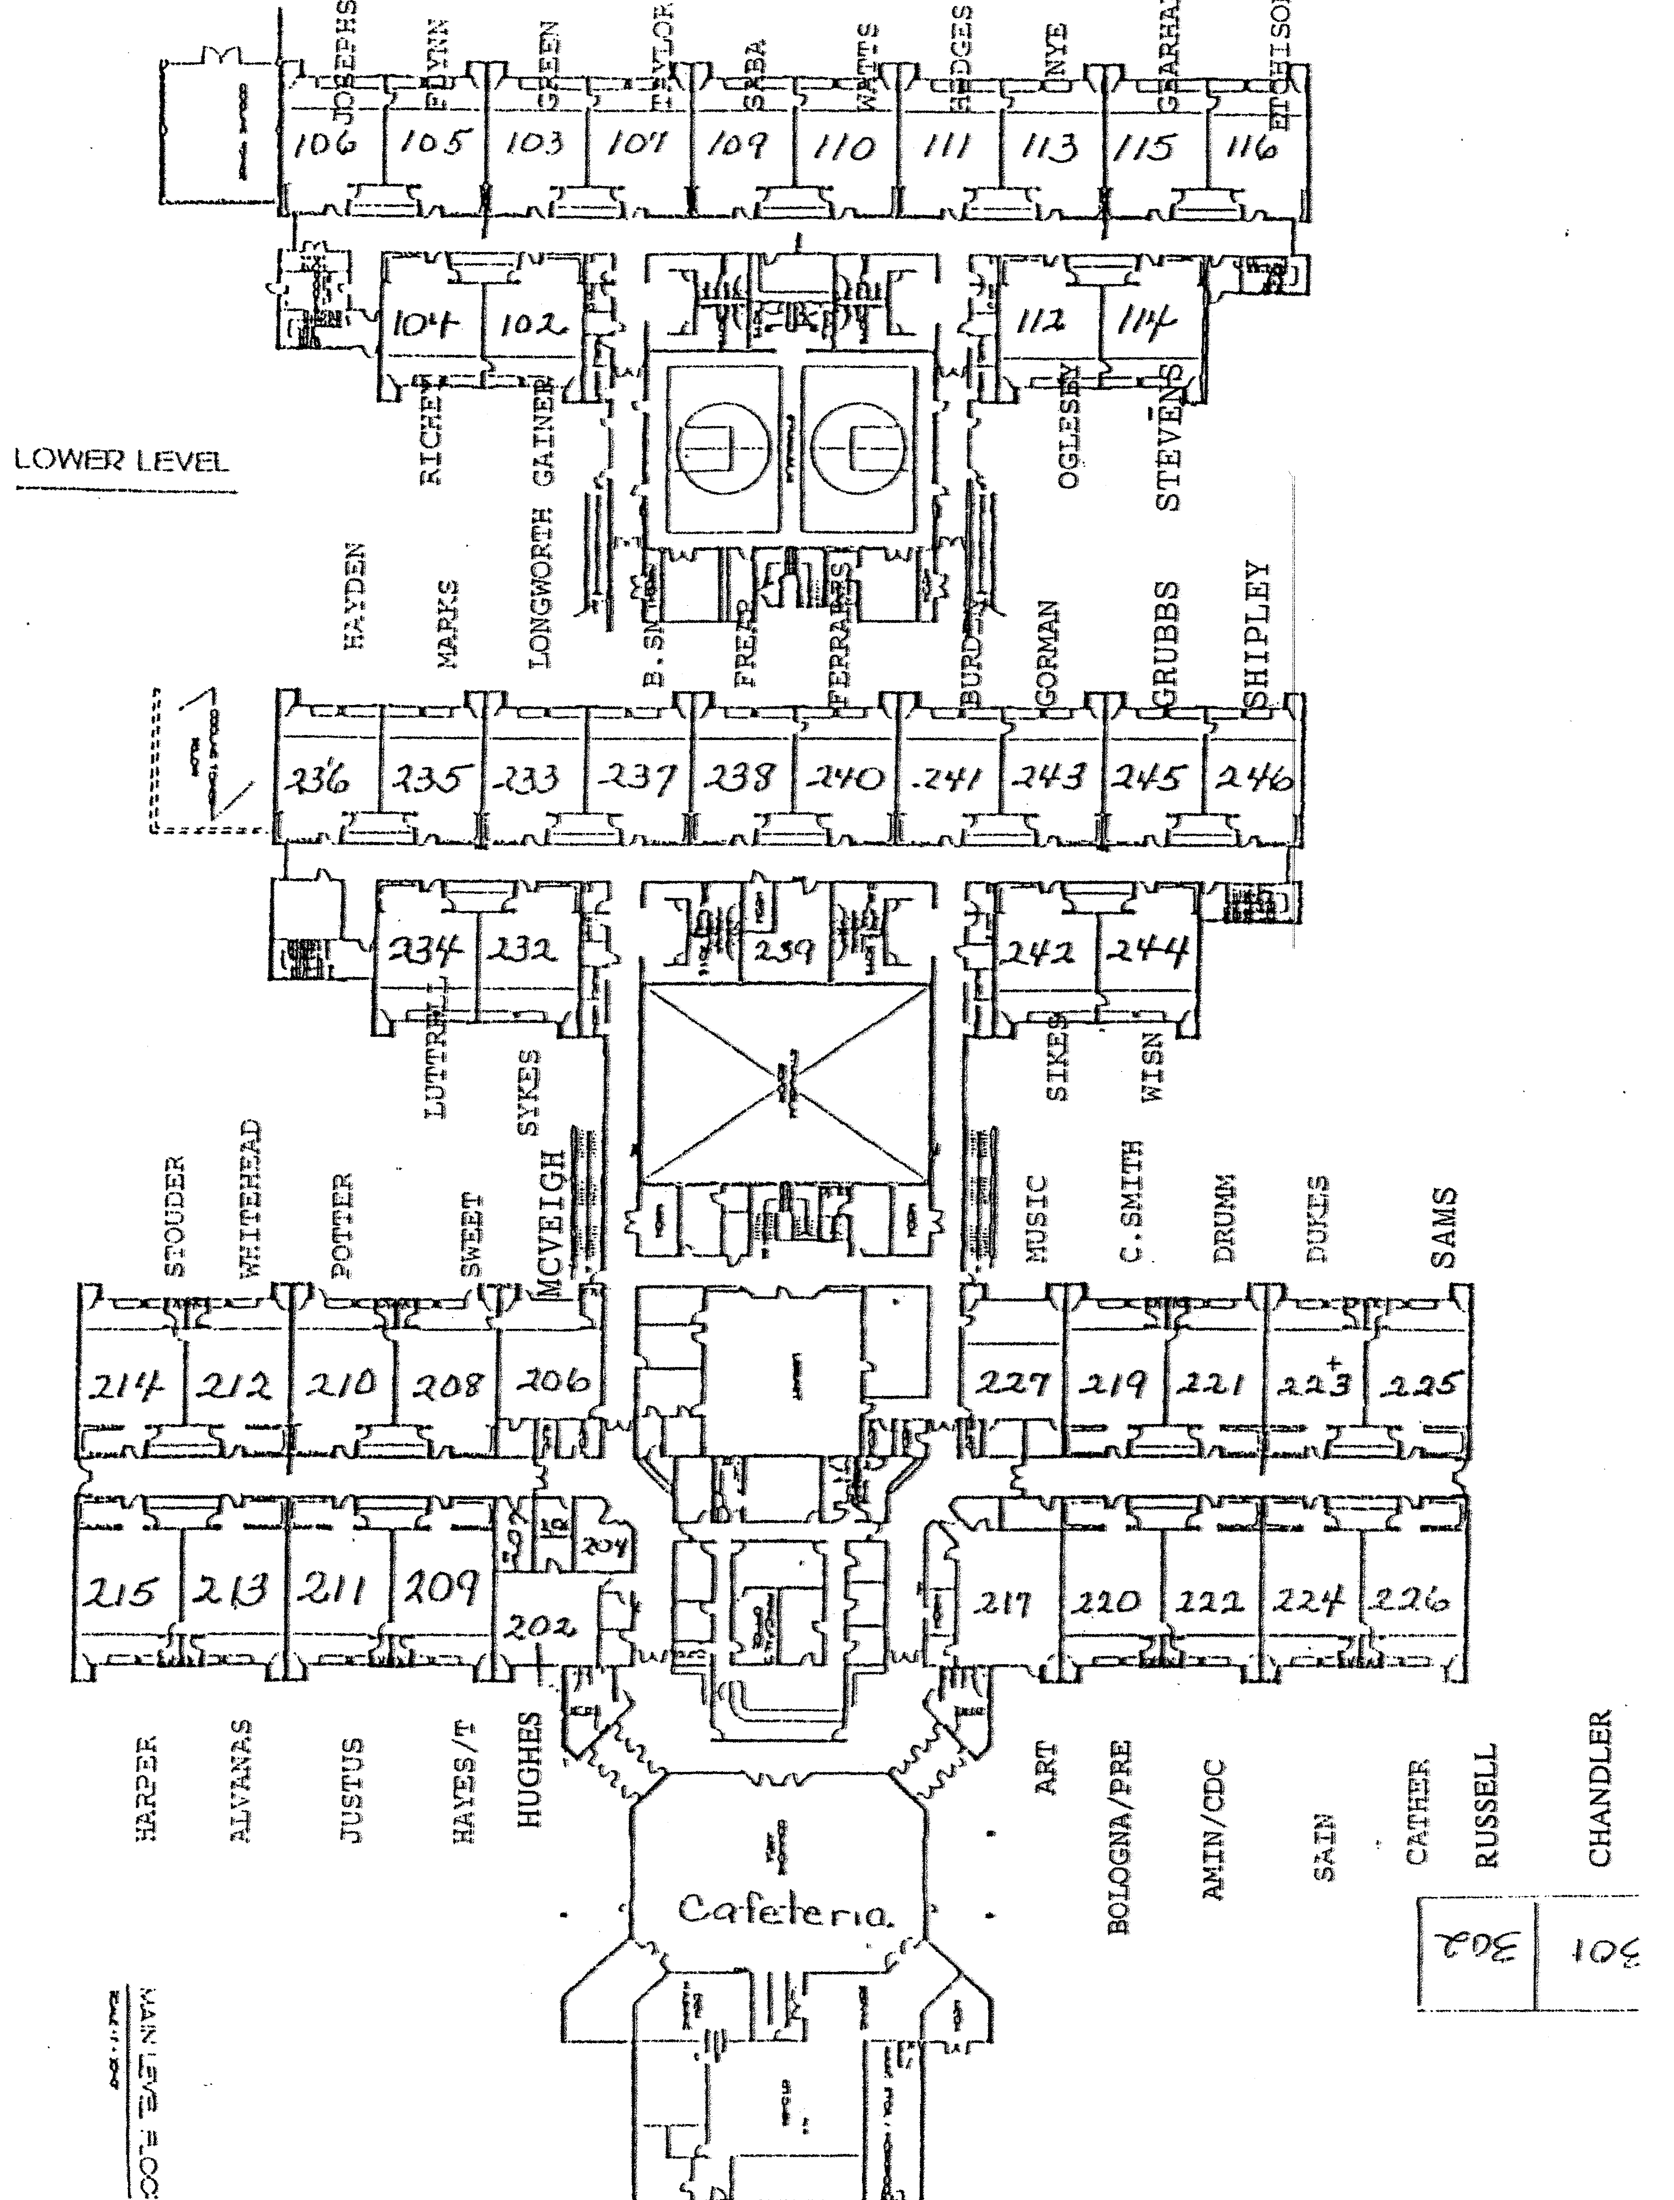

FIRE DRILL PLAN
FARRAGUT PRIMARY SCHOOL
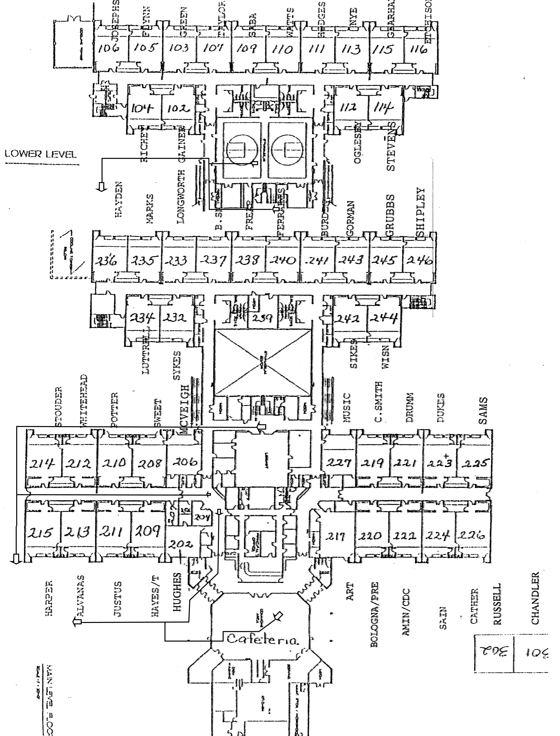

CIVIL DEFENSE PLAN
FARRAGUT PRIMARY SCHOOL
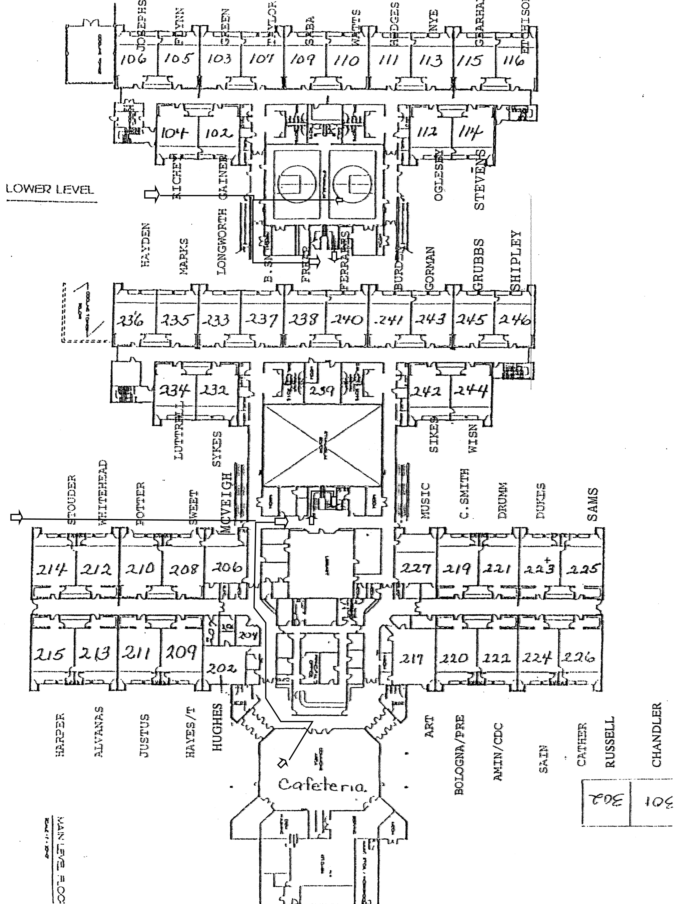

FIRE DRILL PROCEDURES
FARRAGUT PRIMARY SCHOOL

KidTime staff members should become thoroughly familiar with our Fire Drill Procedures. Please discuss and practice this plan carefully and fully with all of the students.

The Fire Drill signal will be the sounding of the alarm.

Drills will be scheduled in advance and made known to the staff and students.

Every area of the building has an assigned exit. If your primary exit route is blocked, you must use your secondary exit route.

The Fire Drill alarm means that all students must stop all talking immediately and automatically. Without disorder, students must form a line which will be led out of the area by an appointed student or member of the staff.

The person leading the line must be familiar with both the primary and secondary exit routes.

Each group of students must follow the designated leader out of the school building. Groups must move in an orderly fashion, without any talking, and as quickly as possible. If a group needs to pass through a doorway, a student should be designated to hold this door open as needed. All drills will be timed.

Once you have cleared the building, your group must continue to move as quickly as possible to a safe location more than fifty feet away from the building and out of any driveway/parking areas. The group must remain in line at this location, where no talking should be permitted. The Director/Counselors will call the roll to ensure that all students have safely reached the assembly point.

All students and counselors will remain at their safe locations until a signal is given.

When the drill has been fully completed, an all clear@ will be made. Still moving in an orderly line with no talking, students should be escorted back into the building.

Any fire alarm other than those publicly scheduled should be regarded as the real thing. Follow these same procedures exactly.

BOMB THREAT DOCUMENTATION

Date and time reported: ________________________________________________
How reported: ________________________________________________________
Exact words of caller: __________________________________________________
_____________________________________________________________________
QUESTIONS TO ASK:
1. When is the bomb to explode? ________________________________________
2. Where is the bomb right now? _________________________________________
3. What kind of bomb is it? ______________________________________________
4. What does it look like? _______________________________________________
5. Where are you calling from? __________________________________________
6. How many bombs are there? _________________________________________
DESCRIPTIONS OF CALLER'S VOICE:
Male_______ Female _______ Young _______ Old _______ Middle aged_______
TONE OF VOICE:
Serious _____ Joking _____ Giggling or laughing _____ Sounded tense ______
Sounded very sorry ______ Sounded unsure ______ Had an accent ______ If so, what kind? ___________ is voice familiar? _______
Were there any background noises? ______________________________________
Time caller hung up: _________________ Action taken: ______________________
Director or designee notified at (time) _______________
Name, title, address, telephone number of call recipient:
__________________________________________________________________________________________________________________________________________
ACTION TAKEN BY RECIPIENT:___________________________________________________________
_____________________________________________________________________
Deliver the message in person to the director.

SOURCES

Farragut Primary School
Gina Byrd, Principal ........................................ 966-5848

Farragut Assembly of God ………………………..966-9991

Knox County Emergency Management Agency (KEMA)
........................................................... 215-2297

Tennessee Department of Human Services
Childcare Emergency Management Training ....... 594-6774

Tennessee Emergency Management Agency (TEMA)
Knoxville......................................... 981-5286

